**A Dissertation Project Report**

on

**“A study on financial derivative”**

SUBMITTED IN PARTIAL FULFILLMENT FOR THE AWARD OF DEGREE OF

**MASTER BUSINESS ADMINISTRATION**

**SUBMITTED BY**

MOHAMMAD SAQUIB

ROLL NO.2300101882

**UNDER THE GUIDANCE OF**

**DR. HABIB UDDIN**

**(ASSISTANT PROFESSOR**)

DEPARTMENT OF BUSINESS MANAGEMENT

INTEGRAL BUSINESS SCHOOL

**INTEGRAL UNIVERSITY**

**LUCKNOW UTTAR PRADESH 226026**

SESSION-2024-25

**DECLARATION**

I hereby declare that the report of the Dissertation Project work titled **"****A study on financial derivative "** is an authentic record of the project work carried out by me under the supervision of **Dr. Habib Uddin** Assistant Professor, Department of Business Management at Integral University, Lucknow. No part of the project work has been presented elsewhere for any other degree or diploma earlier.

I declare that I have faithfully acknowledged and referred to the works of other researchers, wherever their published works have been cited in this report. I further certify that I have not willfully taken other's work, para, text, data, results, tables, figures, etc. Reported in journals. Books, magazines, reports, dissertations, theses, etc., or available on the websites, without their permission.

Date: Signature:

Name: **Mohammad SAQUIB**

Enrollment No:**2300101882**



**CERTIFICATE**

This is to certify that **Mohammad saquib** Enrollment No.**2300104159** has carried out the Dissertation Project entitled **“A study on financial derivative** submitted to the Department of Business Management, Faculty of Commerce & Management, Integral University in partial fulfillment for the award of the Degree of Master of Business Administration from Integral University, Lucknow under my supervision.

It is also certified that

1. This project work embodies the original work of the candidate and has not been earlier submitted elsewhere for the award of any degree.
2. The candidate has worked under my supervision for the prescribed period.

1. The project work fulfills the requirements of the norms and standards prescribed by the Integral University, Lucknow, India.
2. No published work (figure, data, table, etc.) has been reproduced in the thesis without express permission of the copyright owner(s).

Therefore, I deem this work fit and recommend submission for the award of the aforesaid degree.

Signature of Supervisor

**Dr. Habib Uddin**

Department of Business Management

Integral Business School

Integral University,lucknow

Date:

**ACKNOWLEDGEMENT**

First and foremost, I would like to express my utmost gratitude to God, The Almighty, for His abundant blessings and guidance throughout my project journey, enabling me to complete this work.

I am sincerely grateful to Prof. S. W. Akhtar, the Hon’ble Chancellor and Founder of Integral University, Lucknow, for granting me the opportunity to pursue my MBA at Integral University.

I am thankful to Dr. Syed Nadeem Akhtar, the Hon’ble Pro-Chancellor of Integral University, Lucknow, for his blessings and wisdom.

I would like to extend my heartfelt gratitude to Prof. Javed Musarrat, the Hon’ble Vice-Chancellor of Integral University, Lucknow, for his invaluable guidance and support throughout my dissertation work and for providing me with a platform for academic excellence.

Furthermore, I would like to express my sincere gratitude to my supervisor, Dr. Habib Uddin Assistant Professor, Department of Business Management. His unwavering support, patience, and expertise have been instrumental in the completion of this study.

I would like to express my heartfelt gratitude to Dr. Rajiv Ranjan, Professor & Head/Dean Department of Business Management for their insightful suggestions and constant motivation in carrying out this project work.

Once again, I am deeply grateful to all the individuals mentioned above for their unwavering support and contributions to my project journey.

**Mohammad SAQUIB**

**PREFACE**

For a management student, research report plays an important role during his study. Research provides a corporate or real world platform to learn practically. MBA degree without any research or corporate world experience is just like food without salt. So research provides a great learning experience about management concepts and its applications.

This project entitled **" A study on financial derivative** **"** aimed at studying the recruitment of employee of any organization is very important functions because these decide the most suitable manpower which steers the industry to its desired goals.

This project was undertaken as a part of the curriculum of MBA course, which is compulsory for each student to have the research in any organization to their respective specialization, as to gain first-hand knowledge of the organization. This exposure enables the trainees to learn effective and efficient ways and means to solve the real problems faced by the organization and also to understand its dynamics.

**TABLE OF CONTENT**

|  |  |  |
| --- | --- | --- |
| **Sr.No.** | **Title** | **Page No.** |
|  | Declaration | 2 |
| ii. | Certificate of Guide | 3 |
| iii. | Acknowledgement | 4 |
| iv. | Preface | 5 |
| 1 | Conceptual Background | 8­-33 |
| 2 | Literature Review | 34-37 |
| 3 | Research Methodology | 38-48 |
| 4 | Proceeding Of The Task And Completing Of The Task | 49-53 |
| 5 | Learning And Knowledge Gained | 54-58 |
| 6 | Finding,Conclusion,Suggesstion and  Recommendation | 59-60 |
| 7 | Bibliography | 61 |
| 8 | Plagiarism Report | 63 |

**Conceptual Background**

**Introduction to Financial Derivatives**

Financial derivatives are complex financial instruments whose value is derived from the price of an underlying asset. These assets can be anything from stocks, bonds, commodities, interest rates, or even other derivatives. Derivatives are typically used for hedging risk, speculating, or arbitraging. They offer the opportunity to gain or lose money based on changes in the value of the underlying asset, making them highly sensitive to market movements.

Derivatives are an important breed of financial instrument which are central to today‘s financial markets. In India, the derivative market segment is very popular and quite active. It is very clear that in currency markets, commodity markets and stock markets involving all the market participants face considerable risk on account of price fluctuations regarding assets traded in these markets. In a financial market system, derivatives can improve a market‘s efficiency by price discovery, liquidity and transfer of risk. Moreover, investors and business houses use derivatives to hedge or manage their risks. The unfamiliarity and complexity of trading in derivatives has created an air of doubt among the investors inducing them to take differing perspectives on derivative**s.**

**EVOLUTION OF DERIVATIVES**

This text is the 48th law out of 282 contained in the Code of Hammurabi. Hammurabi was a king of Babylon who reigned, according to some sources, from around 1792 to 1750 BC. Hammurabi engraved the eponymous code on stone steles. This code counts among the oldest written body of laws known today and covers almost all the aspects of civil as well as 2 commercial laws of that time. It deals to a great extent with contractual matters, establishing for example the wages to be paid to an ox- driver or to a doctor. It is renowned to be the most complete code of the Mesopotamian laws that have been conserved until today. In terms of contracts, one may recognise in this 48th law a kind of contract that once translated into a more modern language would stipulate the following: A farmer who has a mortgage on his property is required to make annual interest payments in the form of grain, however, in the event of a crop failure, this farmer has the right not to pay anything and the creditor has no alternative but to forgive the interest due. Experts in the field of derivatives would classify such a contract as a put option. In another word: If the harvest is plentiful and the farmer has enough grain to pay his mortgage interest, the put option would expire worthless. If his harvest fell short, however, he would exercise his right to walk away from making thepayment.

**DERIVATIVES DESIGNED BY GREEK PHILOSOPHERS**

A subsequent trace of derivatives in history can be found in Aristotle‘s Politics. Aristotle tells the story of Thales, another philosopher but also mathematician, who lived from around 625 to 550 BC in Miletus, which was one of the major cities of Ancient Greece. During wintertime, Thales predicted an unusually large olive harvest. He seized the opportunity to negotiate with the olive press owners the right, but not the obligation, to hire all the olive presses in the region for the following autumn. To secure this right, Thales made a cash deposit. It happened that the harvest was as predicted and the demand for the use of olive presses soared. Thales was then able to lease the presses at a substantial premium and made a fortune. Aristotle sought to demonstrate how easy it was for philosophers to become rich if they so desired, despite it not being their aim, but he did not seek to create a financial product that experts would today name a call

option.7

**DERIVATIVES IN THE MIDDLE AGES**

In the middle Ages, derivatives continued to be an instrument facilitating trade. One early example of derivatives is a form of command which was used by Italian merchants from the 10th century on. Commandas were a kind of commercial partnership contract for sea or land ventures. One partner put up the money, whereas the other travelled on the venture. Many of these contracts could be considered as commodity forward contracts, as in exchange of the invested capital, the ―venturer‖ agreed to acquire specified commodities. Another example of derivatives is the monti share. Monti shares were issued by Italian

Began as the sale of future government revenues to investors. By the 13th century, these shares were traded in secondary markets and were even used as a means of payment for goods or services instead of cash. Because they were perfectly fungible, these shares were the ideal instrument to develop contracts markets. However, these shares could not be sold freely, in particular to foreigners, and prices fluctuated with the fortunes of the cities. A further example of derivatives is the bill of exchange. Bills of exchange provided a medium of exchange in long distance trade. They were a promise to repay a certain amount of money in a different location, in a different currency and at a future date. Bills of exchange generated a credit as well as a change operation, which were both intimately linked. As trade expanded, the exchange business grew and professional money changers and trading of such

**DERIVATIVE TRADING IN INDIA.**

The origin of derivatives can be traced back to the need of farmers to protect themselves against fluctuations in the price of their crop. From the time it was sown to the time it was ready for harvest, farmers would face price uncertainty. Through the use of simple derivative products, it was possible for the farmer to partially or fully transfer price risks by locking-in asset prices. These were simple contracts developed to meet the needs of farmers and were basically a means of reducing risk.

Derivative markets in India have been in existence in one form or the other for a long time. In the area of commodities, the Bombay Cotton Trade Association started future trading way back in 1875. This was the first organized futures market. Then Bombay Cotton Exchange Ltd. in 1893, Gujarat VyapariMandall in 1900, Calcutta Hesstan Exchange Ltd. in 1919 had started future market. After the country attained independence, derivative market came through a full circle from prohibition of all sorts of derivative trades to their recent reintroduction. In 1952, the government of India banned cash settlement and options trading, derivatives trading shifted to informal forwards markets. In recent years government policy has shifted in favour of an increased role at market based pricing and less suspicious derivatives trading. The first step towards introduction of financial derivatives trading in India was the promulgation at the securities laws (Amendment) ordinance 1995. It provided for withdrawal at prohibition on options in securities. The last decade, beginning the year

**DERIVATIVE TRADING: WHY DO INVESTORS TRADE/INVEST IN DERIVATIVES**

The investors in Ernakulam district has several reasons for investing/trading in derivatives. Table 4.24 reveals that investor‘s rationale behind trading in derivatives is to earn profit by speculation which is ranked 1 with a mean score of 4.86. The next reason for trading is derivatives is to hedge future loss, ranked 2 with mean of 3.73, followed by a mean score of 2.35 with rank 3 the investors choose derivatives to insure their principal investment. Other reasons like setting off previous investment losses and other factors like liquidity, price discovery are ranked 4 and 5 respectively.

Table 4.24: Reasons for derivative trading

|  |  |  |
| --- | --- | --- |
| *Why do you trade/invest in derivatives* | *Mean* | *Rank* |
| Others | 1.67 | 5 |
| To set off previous investment losses | 2.25 | 4 |
| To hedge the risk of future loss | 3.73 | 2 |
| To insure principal investment | 2.35 | 3 |
| To earn profit by speculation | 4.86 | 1 |

Source: Primary data

**DEVELOPMENT OF DERIVATIVE TRADING IN INDIA.**

The first step towards introduction of derivatives trading in India was the promulgation of the Securities Laws (Amendment) Ordinance, 1995, which withdrew the prohibition on options in securities. The market for derivatives, however, did not take off, as there was no regulatory framework to govern trading of derivatives. SEBI set up a 24–member committee under the Chairmanship of Dr.L.C.Gupta on November 18, 1996 to develop appropriate regulatory framework for derivatives trading in India. The committee submitted its report on March 17, 1998 prescribing necessary pre– conditions for introduction of derivatives trading in India. The committee recommended that derivatives should be declared as ‗securities‘ so that regulatory framework applicable to trading of ‗securities‘ could also govern trading of securities. SEBI also set up a group in June 1998 under the Chairmanship of Prof.J.R.Varma, to recommend measures for risk containment in derivatives market in India. The report, which was submitted in October 1998, worked out the operational details of margining system, methodology for charging initial margins, broker net worth, deposit requirement and real–time monitoring requirements. The Securities Contract Regulation Act (SCRA) was amended in December 1999 to include derivatives within the ambit of ‗securities‘ and the regulatory framework were developed for governing derivatives trading. The act also made it clear that derivatives shall be

legal and valid only if such contracts are traded on a recognized stockexchange, thus precluding OTC derivatives. The government also rescinded in March 2000, the three decade old notification, which prohibited forward trading in securities. Derivatives trading commenced in India in June 2000 after SEBI granted the final contracts. To begin with, SEBI approved trading in index futures contracts based on S&P CNX Nifty and BSE–30 (Sense) index. This was followed by approval for trading in options based on these two indexes and options on individual securities.

The trading in BSE Sensex options commenced on June 4, 2001 and the trading in options on individual securities commenced in July 2001. Futures contracts on individual stocks were launched in November 2001. The derivatives trading on NSE commenced with S&P CNX Nifty Index futures on June 12, 2000. The trading in index options commenced on June 4, 2001 and trading in options on individual securities commenced on July 2, 2001. Single stock futures were launched on November 9, 2001. The index futures and options contract on NSE are based on S&P CNX Trading and settlement in derivative contracts is done in accordance with the rules, byelaws, and regulations of the respective exchanges and their clearing house/corporation duly approved by SEBI and notified in the official gazette. Foreign Institutional Investors (FIIs) are permitted to trade in all Exchange traded derivative products.

**DERIVATIVE TRADING IN INDIA.**

The trading in BSE Sensex options commenced on June 4, 2001 and the trading in options on individual securities commenced in July 2001. Futures contracts on individual stocks were launched in November 2001. The derivatives trading on NSE commenced with S&P CNX Nifty Index futures on June 12, 2000. The trading in index options commenced on June 4, 2001 and trading in options on individual securities commenced on July 2, 2001. Single stock futures were launched on November 9, 2001. The index futures and options contract on NSE are based on S&P CNX Trading and settlement in derivative contracts is done in accordance with the rules, byelaws, and regulations of the respective exchanges and their clearing house/corporation duly approved by SEBI and notified in the official gazette. Foreign Institutional Investors (FIIs) are permitted to trade in all Exchange traded derivative products.

The following are some observations based on the trading statistics provided in the NSE report on the futures and options (F&O):

**DEVELOPMENT OF DERIVATIVE**

Futures contracts based on S&P CNX Nifty and BSE–30 Sensex index, which commenced trading in June 2000. Later, trading in Index options commenced in June 2001 and trading in options on individual stocks commenced in July 2001. Futures contracts on individual stocks started in November 2001. In July 2012, SEBI has granted permission to MCX-SX to deal in equity derivatives. Starting from a controlled economy, India has moved towards a world where prices fluctuate every day. The introduction of risk management instruments in India gained momentum in the last few years due to liberalisation process and Reserve Bank of India‘s (RBI) efforts in creating currency forward market. Derivatives are an integral part of liberalisation process to manage risk. NSE gauging the market requirements initiated the process of setting up derivative markets in India. In July 1999, derivatives trading commenced in India. In less than three decades of their coming into vogue, derivatives markets have become the most important markets in the world. Today, derivatives have become part and parcel of the day-to-day life for ordinary people in major part of the world. Until the advent of NSE, the Indian capital market had no access to the latest trading methods and was using traditional out-dated methods of trading. There was a huge gap between the investors‘ aspirations of the markets and the available means of trading. The opening of Indian economy has precipitated the process of integration of India‘s financial markets with the international financial markets

**TYPES AND CLASSIFICATION OF DERIVATIVES.**

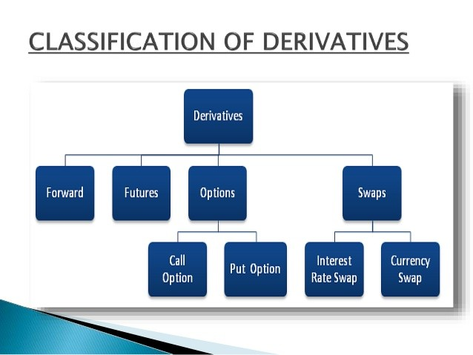

**Figure 3.1: General Classification of Derivatives.**

There are many ways in which the derivatives can be categorized based on the markets where they trade, based on the underlying asset and based on the product feature etc. some ways of classification are following:

On the basis of linear and non-linear: On the basis of this classification the financial derivatives can be classified into two big class namely linear and non- linear derivatives:

* 1. Linear derivatives: Those derivatives whose Over-the-counter (OTC) traded derivative: These values depend linearly on the underlying‘s value are called linear derivatives.

They are following:

* + 1. Forwards.
    2. Futures.
    3. Options.
  1. Non-linear derivatives: Those derivatives whose value is a non-linear function of the underlying are called non-linear derivatives.

They are following:

* + 1. Options.
    2. Convertibles.
    3. Equity linked bonds.

1. On the basis of financial and non-financial: On the basis of this classification the derivatives can be classified into two category namely financial derivatives and non-financial derivatives.
   1. Financial derivatives: Those derivatives which are of financial nature are called financial derivatives.

They are following:

* + 1. Forwards.

###### **FORWARDS.**

A forward contract is a simple customized contract between two parties to buy or sell an asset at a certain time in the future for a certain price. Unlike future contracts, they are not traded on an exchange, rather traded in the over-the-counter market, usually between two financial institutions or between a financial institution and its client.

**Example:**

An Indian company buys Automobile parts from USA with payment of one million dollar due in 90 days. The importer, thus, is short of dollar that is, it owes dollars for future delivery. Suppose present price of dollar is ` 48. Over the next 90 days, however, dollar might rise against ` 48. The importer can hedge this exchange risk by negotiating a 90 days forward contract with a bank at a price ` 50. According to forward contract in 90 days the bank will give importer one million dollar and importer will give the bank 50 million rupees hedging future payment with forward contract. On the due

**FUTURES.**

Futures Contract means a legally binding agreement to buy or sell the underlying security on a future date. Future contracts are the organized/standardized contracts in terms of quantity, quality (in case of commodities), delivery time and place for settlement on any date in future. The contract expires on a pre-specified date which is called the expiry date of the contract. On expiry, futures can be settled by delivery of the underlying asset or cash. Cash settlement enables the settlement of obligations arising out of the future/option contract in cash. Futures contracts represent a step beyond

**Basic mechanism of futures.**

A futures contract calls for the delivery of the specified quantity at the specified rate on specified date. Or, before the maturity date it can be squared off. In India, the financial derivatives (futures) are compulsorily squared off on the maturity date. However, in case of commodities futures, delivery is made, if required, by the transfer of warehouse receipt .An investor can buy (a long position) or sell (a short position) a futures contract. The profit or payoff position of a futures contract depends on the differences between the specified price (of the futures contract) and the actual market price prevailing on the maturity date. For example, if an investor has purchased a futures contract in HLL at the rate of ` 300 and one contract in for 500 shares. The value of the contract is Rs.1,50,000 (` 300x 500). Now, on the maturity date the rate is ` 310. The value of the contract is Rs.1,55,000 and his profit is ` 5,000. Similarly, if the rate is

` 296, then his loss is Rs. 2,000. Further, that if the investor has sold initially, then his loss and profit position would be `Rs.5,000 and Rs. 2,000 respectively. This can be summarized as follows:

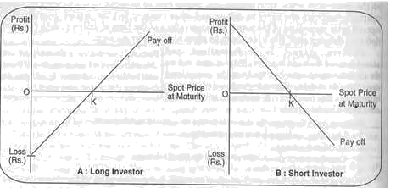

**INDIVIDUAL SECURITIES.**

The positions in the futures contracts for each member is marked-to-market to the daily settlement price of the futures contracts at the end of each trade day. The profits/ losses are computed as the difference between the trade price or the previous day's settlement price, as the case may be, and the current day's settlement price. The Clearing Members who have suffered a loss are required to pay the mark-to-market loss amount to NSCCL which is passed on to the members who have made a profit. This is known as daily mark-to-market settlement. Theoretical daily settlement price for unexpired futures contracts, which are not traded during the last half an hour on a day, is currently the price computed as per the formula detailed as,

F = S * e rt Where:

F = theoretical futures price

S = value of the underlying index r = rate of interest (MIBOR)

t = time to expiration

Rate of interest may be the relevant MIBOR rate or such other rate as may be specified. After daily settlement, all the open positions are reset to the daily settlement price. Clearing Members are responsible to collect and settle the daily mark to market profits /

losses incurred by the TMs and their clients clearing and settling through them. The pay-in and pay-out of the mark-to-market settlement is on T+1 days (T = Trade day). The mark to market losses or profits are directly debited or credited to the Clearing Members clearing bank acco

**Option To Settle Daily MTM On T+0 Day**

Clearing members may opt to pay daily mark to market settlement on a T+0 basis. The option can be exercised once in a quarter (Jan-March, Apr-June, and Jul-Sep & Oct-Dec). Clearing members who wish to opt to pay daily mark to market settlement on T+0 basis shall intimate the Clearing Corporation as per the format specified in specified format. Clearing members who opt for payment of daily MTM settlement amount on a T+0 basis shall not be levied the scaled up margins. The pay-out of MTM settlement shall continue to be done on T+1 day basis.

**Final Settlement**

On the expiry of the futures contracts, NSCCL marks all positions of a CM to the final settlement price and the resulting profit / loss is settled in cash. The final settlement of the futures contracts is similar to the daily settlement process except for the method of computation of final settlement price. The final settlement profit / loss is computed as the difference between trade price and the previous day's settlement price, as the case may be, and the final settlement price of the relevant futures contract. Final settlement loss/ profit amount is debited/ credited to the relevant CMs clearing bank account on T+1 day (T= expiry day).Open positions in futures contracts cease to exist

after their expiration day.

**OPTIONS**

Options Contract is a type of Derivatives Contract which gives the buyer/holder of the contract the right (but not the obligation) to buy/sell the underlying asset at a predetermined price within or at end of a specified period. The buyer / holder of the option purchases the right from the seller/writer for a consideration which is called the premium. The seller/writer of an option is obligated to settle the option as per the termsof the contract when the buyer/holder exercises his right. The underlying asset could include securities, an index of prices of securities etc.

Under Securities Contracts (Regulations) Act, 1956 options on securities has been defined as "option in securities" meaning a contract for the purchase or sale of a right to buy or sell, or a right to buy and sell, securities in future, and includes a teji, a mandi, a teji mandi, a galli, a put, a call or a put and call in securities. An Option to buy is called Call option and option to sell is called Put option. Further, if an option that is exercisable on or before the expiry date is called American option and one that is exercisable only on expiry date, is called European option. The price at which the option is to be exercised is called Strike price or Exercise price.

Therefore, in the case of American options the buyer has the right to exercise the option at any time on or before the expiry date. This request for exercise is submitted to the Exchange, which randomly assigns the exercise request to the sellers of the options, who are obligated to settle the terms of the contract within a specified time frame The contracts cost you $1,665. That is what they were **worth the day you bought them when the** stock was trading at $42 a share. This $1,665 is a small price to pay compared to the $42,000 you would have paid if you bought the stock outright ($42 * 1000 shares).Eight days pass by and the stock price of Humana, Inc. increases in value as you expected. The stock is now trading for $46 a share. Your contract is now worth more money and you essentially turn around and sell it to someone else for let‘s say

$2,534. In doing so, you would make a quick $869 or 52% return on your money.

An option is a contract, which gives the buyer (holder) the right, but not the obligation, to buy or sell specified quantity of the underlying assets, at a specific (strike) price on or before a specified time (expiration date).The underlying may be commodities like wheat/ rice/ cotton/ gold/ oil or financial instruments like equity stocks/ stock index/ bonds etc.

**IMPORTANT TERMINOLOGY**

Underlying - The specific security / asset on which an options contract is.

Option Premium - This is the price paid by the buyer to the seller to

Strike Price or Exercise Price - The strike or exercise price of an option is the specified/ pre-determined price of the underlying asset at which the same can be bought or sold if the option buyer exercises his right to buy/ sell on or before the expiration day.

Expiration date - The date on which the option expires is known as Expiration Date. On Expiration date, either the option is exercised or it expires worthless. Exercise Date - is the date on which the option is exercised. In case of European Options the exercise, date is same as the expiration date while in case of American Options, the options contract may be exercised any day between the purchase of the contract and its expiration date (see European/ American Option)

Open Interest - The total number of options contracts outstanding in the market at any given point of time.

Option Holder: is the one who buys an option which can be a call or a put option. He enjoys the right to buy or sell the underlying asset at a specified price on or before specified time. His upside potential is unlimited while losses are limited to the Premium paid by him to the option writer

.

Option seller/ writer: is the one who is obligated to buy (in case of Put option) or to sell (in case of call Option), the underlying asset in case the buyer of the option decides to exercise his option. His profits are limited to the premium received from the buyer while his downside is unlimited.

Option Class: All listed options of a particular type (i.e., call or put) on a particular underlying instrument,e.g., all Sensex Call Options (or) all Sensex Put Options

**Exercising The Option**

If the holder of an equity option decides to exercise his right to buy (in the case of a call) or to sell (in the case of a put) the underlying shares of stock, the holder must direct his broker (if an Options Clearing Corporation clearing member) to submit an exercise notice to Options Clearing Corporation . In order to ensure that an option is exercised on a particular day, the holder must notify his broker before the broker‘s cut- off time for accepting exercise instructions on that day. Different firms may have different cut-off times for accepting exercise instructions from customers, and those cut- off times may be different for different classes of options. Options Clearing Corporation will then assign this exercise notice to one or more clearing members with short positions in the same series in accordance with its established procedures. If the exercise is assigned to a clearing member‘s customers‘ account, the clearing member will, in turn, allocate the exercise to one or more of its customers (either randomly or on a first in first out basis) who hold short positions in that series. The assigned clearing member will then be obligated to sell (in the case of a call) or buy (in the case of a put) the underlying shares of stock at the specified strike price. Generally speaking, Options Clearing Corporation clearing members settle the delivery and payment obligations arising from the exercise of a physically-settled equity option through the facilities of the correspondent stock clearing corporation.

**Settlement of Options Contracts on Index And Individual Securities**

Premium settlement is cash settled and settlement style is premium style. The premium payable position and premium receivable positions are netted across all option contracts for each CM at the client level to determine the net premium payable or receivable amount, at the end of each day. The CMs who have a premium payable position are required to pay the Premium amount to NSCCL which is in turn passed on to the members who have a premium receivable position. This is known as daily premium settlement.CMs are responsible to collect and settle for the premium amounts from the TMs and their clients clearing and settling through them. The pay-in and pay- out of the premium settlement is on T+1 day (T = Trade day). The premium payable amount and premium receivable amount are directly debited or credited to the CMs clearing bank account. Final Exercise settlement is effected for option positions at in- the-money strike prices existing at the close of trading hours, on the expiration day of an option contract. Long positions at in-the money strike prices are automatically assigned to short positions in option contracts with the same series, on a random basis.

For index options contracts and options contracts on individual securities, exercise style is European style. Final Exercise is Automatic on expiry of the option contracts. Option contracts, which have been exercised, shall be assigned and allocated to Clearing Members at the client level. Exercise

settlement is cash settled by debiting/ crediting of the clearing accounts of the relevant Clearing Members with the respective Clearing Bank. Final settlement loss/ profit amount for option contracts on Index is debited/ credited to the relevant CMs clearing bank account on T+1 day (T = expiry day).Final settlement loss/ profit amount for option contracts on Individual Securities is debited/ credited to the relevant CMs clearing bank account on T+1 day (T = expiry day).Open positions, in option contracts, cease to exist after their expiration day. The pay-in / pay-out of funds for a CM on a day is the net amount across settlements and all

TMs/ clients, in F&O Segment.17

**SWAPS**

A swap is an agreement between two or more people or parties to exchange sets of cash flows over a period in future. Swaps are agreements between two parties to exchange assets at predetermined intervals. Swaps are generally customized transactions. The swaps are innovative financing which reduces borrowing costs, and to increase control over interest rate risk and FOREX exposure. The swap includes both spot and forward transactions in a single agreement. Swaps are at the centre of the global financial revolution.

Swaps are useful in avoiding the problems of unfavourable fluctuation in FOREX market. The parties that agree to the swap are known as counter parties. The two commonly used swaps are interest rate swaps and currency swaps. Interest rate swaps which entail swapping only the interest related cash flows between the parties in the same currency. Currency swaps entail swapping both principal and interest between the parties, with the cash flows in one direction being in a different

The most common type of interest rate swap is one in which Party A agrees to make payments to Party B based on a fixed interest rate, and Party B agrees to make payments to Party A based on a floating interest rate. The floating rate is tied to a reference rate (in almost all cases, the London Interbank Offered Rate, or LIBOR**).**

**Example:**

Assume that Charlie owns a $1,000,000 investment that pays him LIBOR + 1% every month. As LIBOR goes up and down, the payment Charlie receives changes. Now assume that Sandy owns a $1,000,000 investment that pays her 1.5% every month. The payment she receives never changes. Charlie decides that that he would rather lock in a

**MARKET PARTICIPANTS IN DERIVATIVE MARKET**

There are broadly three types of participants in the derivatives market - hedgers, traders (also called speculators) and arbitrageurs. An individual investor may play different roles in different market circumstances.

**Hedgers:** They face risk associated with the prices of underlying assets and use derivatives to reduce their risk. Corporations, investing institutions and banks all use derivative products to hedge or reduce their exposures to market variables such as interest rates, share values, bond prices, currency exchange rates and commodity prices**.**

**Speculators:** They try to predict the future movements in prices of underlying assets and based on the view, take positions in derivative contracts. Derivatives are preferred over underlying asset for speculation purpose, as they offer leverage, are less expensive (cost of transaction is generally lower than that of the underlying) and are faster to execute in size (high volumes market).

**Arbitrageurs:** Arbitrage is a deal that produces profit by exploiting a price difference in a product in two different markets. Arbitrage originates when a trader purchases an asset cheaply in one location and simultaneously arranges to sell it at a higher price in another location. Such opportunities are unlikely to persist for very long, since arbitrageurs would rush in to these transactions, thus closing the price gap at different

locations.19

**DERIVATIVES MARKET IN INDIA**

In India, there are two major markets namely National Stock Exchange (NSE) and Bombay Stock Exchange (BSE) along with other Exchanges of India are the market for derivatives.

**DERIVATIVE PRODUCTS TRADED AT BSE.**

The BSE started derivatives trading on June 9, 2000 when it launched ―Equity derivatives (Index futures-SENSEX) first time. It was followed by launching various products which are shown in table no.2. They are index options, stock options, single stock futures, weekly options, and stocks for: Satyam, SBI, Reliance Industries, Tata Steel, Chhota (Mini) SENSEX, Currency futures, US dollar-rupee future and BRICSMART indices derivatives.

**DERIVATIVE PRODUCTS TRADED AT NSE**

The NSE started derivatives trading on June 12, 2000 when it launched ―Index Futures S & P CNX Nifty‖ first time. It was followed by launching various derivative products. They are index options, stock options, stock future, interest rate, future CNX IT future and options, Bank Nifty futures and options, CNX Nifty Junior futures and options, CNX100 futures and options, Nifty Mid Cap-50 future and options, Mini index futures and options, Long term options. Currency futures on USD-rupee, Defty future and options, interest rate futures, SKP CNX Nifty futures on CME, European style stock options, currency options on USD INR, 91 days GOI T.B. futures, and derivative global indices and infrastructures indices. Subsequently, Various other products were introduced and presently futures and options contracts on the following products are available at NSE:

**TRENDS IN DERIVATIVES SEGMENT**

**EquityDerivatives:**India is one of the vibrant markets for exchange trade dequity derivatives in the world.The trading volumes in the equity derivative market surpassed that of the cash segment turnover by1 1.2 times in December 2015. The monthly total turn over in equity derivative marketat NSE increased by 6.5 percent to Rs.46,31,172 crore in December 2015 from Rs.43,47,054 crore in November 2015 (Figure3.04). The index options segment has been the clear leader in the product-wise turn over of the futuresandoptions segment in the NSE. In December 2015, the turnover in the index options category was 73.8 percent of the total turnover in the F&O segment of the NSE. During December 2015, index futures, stock futures, index options and stock options recorded increases in turnover over the previous month. The open interest in value terms in equity derivative segment of NSE decreased by 14.4 percent to Rs.1,54,964 crore as on December 31, 2015 from Rs.1,81,087 crore as on November 30, 2015.

The index options segment has been the clear leader in the product-wise turn over of the futuresandoptions segment in the NSE. In December 2015, the turnover in the index options category was 73.8 percent of the total turnover in the F&O segment of the NSE. During December 2015, index futures, stock futures, index options and stock options recorded increases in turnover over the previous month. The open interest in value terms in equity derivative segment of NSE decreased by 14.4 percent to Rs.1,54,964 crore as on December 31, 2015 from Rs.1,81,087 crore as on November 30, 2015.

**Table 3.2 : Trends in Equity Derivatives Market**



|  |  |  |  |  |  |  |  |
| --- | --- | --- | --- | --- | --- | --- | --- |
| ***Call*** |  | **39,419** | **47,431** | **-16.9** | **2** | **19** | **-89.4** |
| **(iii)StockFutures** | | **60,744** | **61,986** | **-2.0** | **1** | **2** | **-32.0** |
| **(iv) OptionsonStock** | |  |  |  |  |  |  |
| ***Put*** |  | **1,932** | **3,100** | **-37.7** | **6** | **9** | **-36.0** |
| ***Call*** |  | **3,429** | **5,464** | **-37.2** | **0** | **4** | **-97.3** |
| **Total** | | **1,54,964** | **1,81,087** | **-14.4** | **235** | **272** | **-13.4** |
| **D.OpenInterestintermsofNoofContracts** | | | | | | | |
| **(i)** | **IndexFutures** | **3,20,341** | **3,35,105** | **-4.4** | **4,289** | **4,171** | **2.8** |
| **(ii)** | **OptionsonIndex** |  |  |  |  |  |  |
| ***Put*** |  | **5,23,583** | **7,41,448** | **-29.4** | **43** | **368** | **-88.3** |
| ***Call*** |  | **6,66,610** | **8,03,973** | **-17.1** | **38** | **364** | **-89.6** |
| **(iii)StockFutures** | | **12,04,470** | **12,30,246** | **-2.1** | **29** | **43** | **-32.6** |
| **(iv) OptionsonStock** | |  |  |  |  |  |  |
| ***Put*** |  | **38,932** | **61,430** | **-36.6** | **81** | **204** | **-60.3** |
| ***Call*** |  | **67,861** | **1,07,460** | **-36.8** | **2** | **79** | **-97.5** |
| **Total** | | **28,21,797** | **32,79,662** | **-14.0** | **4,482** | **5,229** | **-14.3** |

**FIG : Trends of Equity Derivatives at NSE (Crores).**

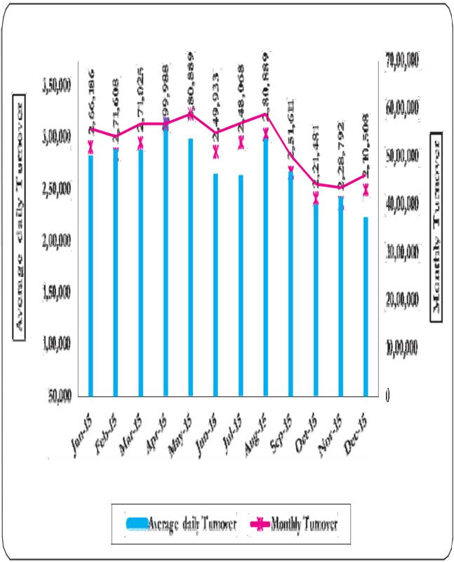

The monthly total turnover in equity derivative segment of BSE increased by 13.9 percent to `1,20,288 crore in December2015 from `1,05,526 crore in November 2015. While index options comprised 94.5 percent of BSE‘s equity derivative turnover, stock options constituted 5.2 percent. During December 2015, index futures, stock futures, index options and stock futures recorded increases in turnover over the previous month. The open interest in value terms inequity derivative segment of BSE decreased by 13.4 percent to `235 crore as on December 31, 2015 from 272 crore as on November 30, 2015. In December 2015, NSE had 97.5 percent share in total equity derivatives turnover in India while BSE‘s share was 2.5 percent. In terms of open interest (in value terms), NSE had 99.85 percent share while BSE had 0.15 percent share.

**PERCEPTION OF INVESTORS TOWARDS FINANCIAL DERIVATIVES**

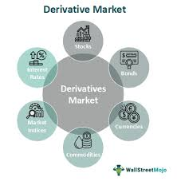

**PROFILE OF THE RESPONDENTS**

The survey was conducted among the 175 investors in Ernakulam District. The investors were categorized on the basis of age, sex, education, occupation and monthly income. The influences of demographic control variables, that is, gender, age, education, income levels, and occupation towards the various accepts of financial literacy. The analyses were conducted using independent sample Z test and one way ANOVA.

**GENDER WISE CLASSIFICATION OF INVESTORS**

Table 4.2 states that gender wise classification of the respondents in Ernakulam district. 84 percent of the respondent constitute male respondents and 16 per cent are female respondents

|  |  |
| --- | --- |
| Male | Female |

. **Gender wise classification of Respondents**

|  |  |  |
| --- | --- | --- |
| **Gender** | **Responses** | **Percent** |
| Male | 147 | 84.0 |
| Female | 28 | 16.0 |
| Total | 175 | 100 |

|  |  |
| --- | --- |
| Female | Male |
|  |  |

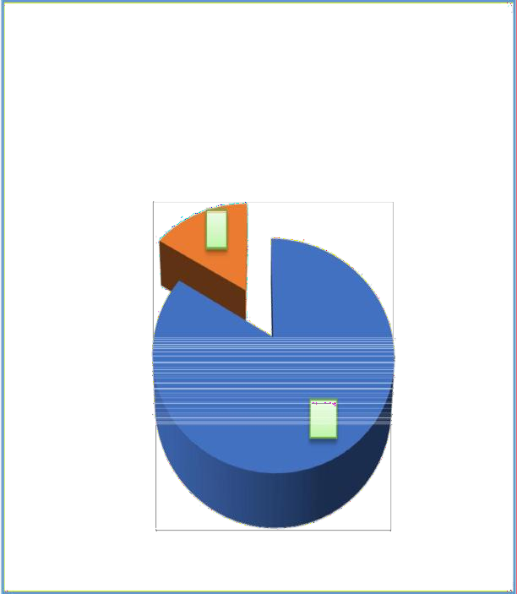

: There is no significant difference in satisfaction level of male and female investors.

H1a: There is significant difference in satisfaction level of male and female investors.

An independent sample Z test are often used to compare the satisfaction level of variables for two different groups of participants, that is, male and female investors.

Hence a Z test was conducted, and the results were shown in the Table

|  |  |  |  |  |  |  |
| --- | --- | --- | --- | --- | --- | --- |
| ***Variable*** | ***Gender*** | ***N*** | ***Mean*** | ***Std.***  ***Deviation*** | ***z*** | ***p value*** |
| Level of satisfaction | Male | 147 | 28.40 | 4.43 | 1.621 | 0.107 |
| Female | 28 | 26.86 | 5.54 |  |  |

**Standard deviation and z value for Gender.**

Source: Primary data

The result shows that no significant difference in the satisfaction level exist between

the male and female investors as the p value in these cases is greater than 0.05. So

we accept the *H0a* hypothesis

**AGE WISE CLASSIFICATION OF INVESTORS**

Age wise classification of respondents are presented in the Table 4.4. The table reveals that majority (41.7 percent) of the respondents are included in the 31–40 category. 30.3 percent of the respondents are 20-30 years‘ category. 16 percent of the respondents are 41-50 category and only 12 percent of the respondents were above 50 age category.

**Table 4.4: Age wise classification of Respondents.**

|  |  |  |
| --- | --- | --- |
| **Category** | **Respondents** | **Percent** |
| 20-30 years | 53 | 30.3 |
| 31-40 years | 73 | 41.7 |
| 41-50 years | 28 | 16.0 |
| Above 50 | 21 | 12.0 |
| Total | 175 | 100.0 |

**Age wise classification of investors:**

|  |  |  |  |  |  |  |
| --- | --- | --- | --- | --- | --- | --- |
| ***Variable*** | ***Age*** | ***N*** | ***Mean*** | ***Std.*** | ***F*** | ***p value*** |
| ***Deviation*** |
|  | 20-30 years | 53 | 24.92 | 5.59 |  |  |
| Level of | 30-40 years | 73 | 28.30 | 3.62 | 23.220 | <0.001 |
| satisfaction | 40-50 years | 28 | 31.14 | 1.84 |  |  |
|  | 50&above | 21 | 31.81 | 0.40 |  |  |

The results of the ANOVA reveals that assumed significance value( p) is less than 0.05. The results proved that the level of satisfaction differ with age. We reject the

hypothesis H0b.Since the ANOVA test indicate that the significant difference exists among the different Age group for the Satisfaction.

**Table 4.6: Multiple Comparison Of Age Groups**

|  |  |  |  |  |
| --- | --- | --- | --- | --- |
| **(I) Age** | | **Mean Difference (I-J)** | **Std. Error** | **Sig.** |
| 20-30 years | 30-40 years | -3.37684* | .71225 | .000 |
| 40-50 years | -6.21833* | .92209 | .000 |
| 50&above | -6.88500* | 1.01769 | .000 |
| 30-40 years | 20-30 years | 3.37684* | .71225 | .000 |
| 40-50 years | -2.84149* | .87734 | .001 |
| 50&above | -3.50815* | .97733 | .000 |
| 40-50 years | 20-30 years | 6.21833* | .92209 | .000 |
| 30-40 years | 2.84149* | .87734 | .001 |
| 50&above | -.66667 | 1.13935 | .559 |
| 50&above | 20-30 years | 6.88500* | 1.01769 | .000 |
| 30-40 years | 3.50815* | .97733 | .000 |
| 40-50 years | .66667 | 1.13935 | .559 |

The present study was also conducted a post hoc test (multiple comparison test) for identify which among the age group differs significantly. This was presented in the Table 4.6.

The result of the analysis indicates that differences exist between all the groups except 40-50 years and above 50 years.

**OCCUPATION WISE CLASSIFICATION OF INVESTORS**

Occupation wise classificationreveals that 60 percent of the respondents are private sector employees, 16.6 percent are professionals, 9.1 percent are businessmen and rest of the respondents are government servants, retired employees and others engaged in daily wage activities and unemployed persons. This was exhibited in the Table 4.9.

**Table 4.9: Occupation wise classification of the respondents**

|  |  |  |
| --- | --- | --- |
| **Occupation** | **Respondents** | **Percent** |
| Government/Semi-Government service | 8 | 4.6 |
| Private sector | 105 | 60.0 |
| Business | 16 | 9.1 |
| Professional Practice | 29 | 16.6 |
| Professional | 4 | 2.3 |
| Others | 13 | 7.4 |
| Total | 175 | 100.0 |

Source: Primary data

Figu4.4 showedthe occupation wise classification of investors. Majority of the respondents are private sector employees (60 percent), followed by professionals (16.6 percent), businessmen (9.1percent) andothers (including daily wage earners and unemployed persons) which constitute 7.4 percent

**INCOME WISE CLASSIFICATION OF INVESTORS**

The income wise classification of investors are presented in the table 4.12. The results shows that majority of the respondents (37.7 percent) earn Rs. 41,000 to Rs. 50,000 per month. Around 30.3 percent of the respondents earn more than Rs. 50,000 per month. 20.6 percent of the respondent earn Rs. 31,000 to Rs. 40,000 per month.

**Table 4.12: Income wise classification**

|  |  |  |
| --- | --- | --- |
| **Monthly income** | **Respondents** | **Percent** |
| Rs. 20000 to Rs.30000 | 20 | 11.4 |
| Rs. 31,000 to Rs. 40,000 | 36 | 20.6 |
| Rs.41, 000 to Rs 50,000 | 66 | 37.7 |
| Rs 50,000 and above | 53 | 30.3 |
| Total | 175 | 100.0 |

Source: Primary data

Figure 4.5 illustrate the monthly income of the investors in Ernakulam district. Out of the 175 respondents, 37.7 percent earn a monthly income of Rs. 41,000 to Rs. 50,000, followed by 30.3 percent of the respondents‘ earnings was above Rs. 50,000.

20.6 percent of respondent earns monthly income of Rs. 31,000 to Rs. 40,000

|  |  |  |  |  |
| --- | --- | --- | --- | --- |
| **(I) Occupation** | | **Mean** | **Std.** | **Sig.** |
| **Difference** |
| **Error** |
| **(I-J)** |
|  | Private sector | 4.48095* | 1.480 | 0.003 |
| Government/Semi- | Business | 7.25000* | 1.747 | 0.000 |
| Government | Professional Practice | 0.259 | 1.612 | 0.873 |
| service | Professional | -0.500 | 2.471 | 0.840 |
|  | Others | -0.500 | 1.813 | 0.783 |
| Private sector | Government/Semi-Government service | -4.48095* | 1.480 | 0.003 |
| Business | 2.76905* | 1.083 | 0.011 |
| Professional Practice | -4.22233* | 0.847 | 0.000 |
| Professional | -4.98095* | 2.056 | 0.016 |
| Others | -4.98095* | 1.187 | 0.000 |
| Business | Government/Semi-Government service | -7.25000* | 1.747 | 0.000 |
| Private sector | -2.76905* | 1.083 | 0.011 |
| Professional Practice | -6.99138* | 1.257 | 0.000 |
| Professional | -7.75000* | 2.256 | 0.001 |
| Others | -7.75000* | 1.507 | 0.000 |
|  | Government/Semi-Government service | -0.259 | 1.612 | 0.873 |
| Professional | Private sector | 4.22233* | 0.847 | 0.000 |
| Practice | Business | 6.99138* | 1.257 | 0.000 |
|  | Professional | -0.759 | 2.152 | 0.725 |
|  | Others | -0.759 | 1.347 | 0.574 |
| Professional | Government/Semi-Government service | 0.500 | 2.471 | 0.840 |
| Private sector | 4.98095* | 2.056 | 0.016 |
| Business | 7.75000* | 2.256 | 0.001 |
| Professional Practice | 0.759 | 2.152 | 0.725 |
| Others | 0.000 | 2.307 | 1.000 |
| Others | Government/Semi-Government service | 0.500 | 1.813 | 0.783 |
| Private sector | 4.98095* | 1.187 | 0.000 |
| Business | 7.75000* | 1.507 | 0.000 |
| Professional Practice | 0.759 | 1.347 | 0.574 |
| Professional | 0.000 | 2.307 | 1.000 |

**Table 4.11: Multiple Comparisons**

**EXPERIENCE WISE CLASSIFICATION OF RESPONDENTS**

An insight into the derivative trading showed that the experience of respondents in the stock market has a significant role in derivative trading. Majority of the respondents (51.9 percent) has an experience of 5 years and below, followed by respondents (38.9 percent) with 6 to 10 years. Hardly 2.9 percent of respondents has an experience ranging from 15 years and above.

**Table 4.15: Experience wise classification of Respondents**

|  |  |  |
| --- | --- | --- |
| **Experience in stock market** | **Frequency** | **Percent** |
| 5years and below | 90 | 51.4 |
| 6 to 10 years | 68 | 38.9 |
| 11 to 15 years | 12 | 6.9 |
| 15 years and above | 5 | 2.9 |
| Total | 175 | 100 |

**Source : Primary Data**

Figure 4.6 shows that experience of investors in the stock market. Out of the 175 respondents 51.4 percent has an experience of 5 years and below. Investors (38.9 percent) had an experience ranging from 6 to 10 years. The remaining respondents (6.9 and 2.9 percent) had an experience of more than 10 years.

**EXPERIENCE IN DERIVATIVE TRADING**

In Table 4.16 the experience wise classification of the investors engaged in

derivative trading shows that most of the investors(34.3 percent)

trading in derivatives has an experience of 3 to 4 years, followed by

investors (30.9 percent) with an experience of 1 year or less. Out of the

175 investors, 29.7 percent of the investors had an experience ranging

from 1 to 2 years**.**

|  |  |  |
| --- | --- | --- |
| ***Years of experience in derivatives trading*** | ***Frequency*** | ***Percent*** |
| **Less than 1 year** | **54** | **30.9** |
| **1 to 2 years** | **52** | **29.7** |
| **3 to 4 years** | **60** | **34.3** |
| **5 years and above** | **9** | **5.1** |
| **Total** | **175** | **100** |

**Experience in Derivative trading**

**Source: Primary data**

### Experience in derivatives trading

60

50

40

30

20

10

0

Less than 1 year 1 to 2 years 3 to 4 years 5 years and

above

**SATISFACTION LEVEL OF INVESTORS IN DERIVATIVE TRADING**

The present study uses Structural Equation Model for testing the following hypothesis. H1: Making good returns from derivative markets (LS1) is an essential part (or measures) for investor satisfaction in derivative trading.

H2: Trading in Future and Options is convenient (LS2) is an essential part for investor satisfaction in derivative trading. H3: Awareness about how to trade in derivative (LS3) is an essential part for investor satisfaction in derivative trading.

H4: Helping in fair price determination (LS4) is an essential part for investor satisfaction in derivative trading.

H5: Enhancing liquidity in the market (LS5) is an essential part for investor satisfaction in derivative trading.

H6: Market offers wide variety of derivatives to hedge risk (LS6) is an essential part for investor satisfaction in derivative trading.

H7: Development of innovative financial products (LS7) is an essential part for investor satisfaction in derivative trading.

H8: Increase in volume of derivative trading (LS8) is an essential part for investor satisfaction in derivative trading.

**FREQUENCY IN FUTURE AND OPTIONS**

**DERIVATIVETRADING**

The frequency in derivative trading in among investors in Ernakulam district is shown in the Table 4.17. Majority of the investors in Ernakulam (39.4 percent) trade in derivatives frequently. Investors doing occasional trading constitute 34.9 percent. Only

|  |  |  |
| --- | --- | --- |
| ***How frequently do you trade*** | ***Frequency*** | ***Percent*** |
| ***in derivatives*** |
| **Rarely** | **20** | **11.4** |
| **Occasionally** | **61** | **34.9** |
| **Frequently** | **69** | **39.4** |
| **Always** | **25** | **14.3** |
| **Total** | **175** | **100** |

**Source: Primary data**

Figure 4.8, shows the frequency of derivative trading among 175 respondents. The figure shows that almost every investor in Ernakulam is trading in derivatives frequently (39.4 percent), followed by investors doing occasional trading (34.9 percent). Only 14.3 percent of investors are always engaged in Future and Options

**FUTURE AND OPTIONS TRADING – RISK ENDURANCE**

**Table 4.18 shows the level of risk tolerance among the investors engaged in Futures and Options trading in Ernakulam District. Among the 175 investors, 48.6 percent are ready to accept a medium level of risk in their investment.26.3 percent of the investors are willing to face high level of risk in their investment meanwhile only 16 and 9.1 percent of the investors ready to take very low risk on their investment.**

**Table 4.18: Investor’s personal level of tolerance for investment risk**

|  |  |  |
| --- | --- | --- |
| ***Personal level of tolerance for*** | ***Frequency*** | ***Percent*** |
| ***investment risk*** |
| Very Low | 16 | 9.1 |
| Low | 28 | 16.0 |
| Medium | 85 | 48.6 |
| High | 46 | 26.3 |
| Total | 175 | 100 |

Source: Primary Data

**The investor‘s level of risk endurance in their investment is shown in the figure**

**The results (refer to Table4. 26) revealed that the Helping in fair price**

**determination has significant influence on Level of satisfaction as the standardized direct effect of this construct on Level of satisfaction was 0.327, which is less than 0.4**

**(*p* value was significant). So we reject the hypothesis H4 and conclude that helping in fair price determination (LS4) has no significant influence on Level of satisfaction.**

**H5: Enhancing liquidity in the market (LS5) is an essential part for investor satisfaction in derivative trading**

**The results (refer to Table 4.26) revealed that Enhancing liquidity in the market**

**has significant influence on Level of satisfaction as the standardized direct effect of this construct on Level of satisfaction was 0.453, which is more than 0.4 (also *p* value was**

**significant). So we accept the hypothesis H5 and conclude that Enhancing liquidity in the market (LS5) has significant influence on Level of satisfaction.**

**H6: Market offers wide variety of derivatives to hedge risk (LS6) is an essential part for investor satisfaction in derivative trading.**

**The results (refer to Table 4.26) revealed that Market offers wide variety of**

**derivatives to hedge risk has significant influence on Level of satisfaction as the standardized direct effect of this construct on Level of satisfaction was 0.174, which is**

**less than 0.4 (also *p* value was significant). So we reject the hypothesis H6 and conclude**

**DERIVATIVE TRADING**

**Table 4.23 shows the factors which influenced the investors in choosing futures and options trading in Ernakulam district. The most influencing factor which behind derivative trading is the opinion the experts and professionals which has been ranked 1 with a mean of 4.98. The next best source of influence is the opinion of the stock broker which is ranked 2 with a mean score of 4. After stock brokers, respondents are channelized in to derivative trading by the influence of channels and media, ranked 3 with a mean of 2.63. Apart from the above, the sources like friends and relatives and others (seminars, conferences etc.) have been ranked 4 and 5 respectively**.

**Table 4.23: Sources influenced in derivative Trading**

|  |  |  |
| --- | --- | --- |
| ***Sources which influenced you to choose derivative trading*** | ***Mean*** | ***Rank*** |
| Stock broker | 4.00 | 2 |
| Friends/relatives | 2.07 | 4 |
| Channels / media | 2.63 | 3 |
| Others | 1.32 | 5 |
| Experts/experienced people | 4.98 | 1 |

**PERFORMANCE OF DERIVATIVE MARKET**

Structural Equation Model is used to identify the factors which can modulate derivative market efficiently. The following hypothesis are tested;

H1: High Margins is a factor which modulate derivative market efficiently.

H2: Adequate awareness is a factor which modulate derivative market efficiently. H3: Monitoring of high volume/ value trades is a factor which modulate derivative market efficiently.

H4: Periodic Training to Market Participants is a factor which modulate derivative

market efficiently.

H5: Monitoring Speculative tendencies is a factor which modulate derivative market efficiently.

H6: Ensuring basic compliance for competent Market Participants is a factor which modulate derivative market efficiently**.**

**Table 4.30:Model fit Indices for CFA Modulating Factor.**

|  |  |  |  |  |  |  |  |  |  |  |  |
| --- | --- | --- | --- | --- | --- | --- | --- | --- | --- | --- | --- |
|  | **χ2** | **DF** | **P** | **Normed χ2** | **GFI** | **AGFI** | **NFI** | **TLI** | **CFI** | **RMR** | **RMSEA** |
| Factors | 10.682 | 2 | .005 | 5.341 | .980 | .787 | .991 | .947 | .993 | .022 | .158 |

**All the attributes loaded significantly on the latent constructs. The value of the fit indices indicates a reasonable fit of the measurement model with data. In short, the measurement model confirms to the factor structure of the constructs. In table 4.31we present the regression coefficients.**

**DIFFICULTY IN FUTURES AND OPTIONS TRADING**

By using Structured Equation Model we test the following hypothesis;

H1: Maintaining margin money is major problem in derivative trading.

H2: Complexity of the instrument is major problem in derivative trading. H3: Lack of sufficient training is major problem in derivative trading.

H4: High speculation is major problem in derivative trading.

H5: Futures and Options are available in odd lots is major problem in

derivative trading.

H6: Misleading tips and advertisement is major problem in derivative trading.

H7: Huge volatility is major problem in derivative trading.

H8: Lack of timely information is major problem in derivative trading.

H9: Other factors are a major problem in derivative trading.

**: Model fit Indices for CFA Problem**

|  |  |  |  |  |  |  |  |  |  |  |  |
| --- | --- | --- | --- | --- | --- | --- | --- | --- | --- | --- | --- |
|  | **χ2** | **DF** | **P** | **Normed** | **GFI** | **AGFI** | **NFI** | **TLI** | **CFI** | **RMR** | **RMSEA** |
| **χ2** |
| **Problems** | **48.660** | **18** | **.000** | **2.703** | **.942** | **.856** | **.901** | **.865** | **.932** | **.023** | **.099** |

**Source: Primary data**

All the attributes loaded significantly on the latent constructs. The value of the fit indices indicates a reasonable fit of the measurement model with data. In short, the measurement model confirms to the factor structure of the constructs. In table 4.29 we present the regression coefficients.

**BARRIERS IN DERIVATIVE TRADING**

The Structural Equation Model is used to identify the reasons behind comparatively less derivative trading in Kerala. The following hypothesis were formulated for explaining the Structural Equation Model;

H1: Lack of technical and fundamental knowledge is a reason behind comparatively less derivative trading in Kerala.

H2: Lack of awareness is a reason behind comparatively less derivative trading in Kerala.

H3: Misleading information is a reason behind comparatively less derivative trading in Kerala.

H4: Risk involved is a reason behind comparatively less derivative trading in Kerala. H5: There are some **other reasons behind comparatively less derivative trading in Kerala.**

**Table 4.32: Model fit Indices for CFA for reasons behind comparatively less derivative Trading in Kerala**

|  |  |  |  |  |  |  |  |  |  |  |  |
| --- | --- | --- | --- | --- | --- | --- | --- | --- | --- | --- | --- |
|  | **χ2** | **DF** | **P** | **Normed χ2** | **GFI** | **AGFI** | **NFI** | **TLI** | **CFI** | **RMR** | **RMSEA** |
| **Reasons** | **7.530** | **4** | **.110** | **1.883** | **.982** | **.933** | **.923** | **.899** | **.960** | **.018** | **.071** |

**All the attributes loaded significantly on the latent constructs. The value of the fit indices indicates a reasonable fit of the measurement model with data. In short, the measurement model confirms to the factor structure of the constructs. In Table 4.33 we present the regression coefficients**

**The regression Coefficients –Reasons.**

|  |  |  |  |  |  |
| --- | --- | --- | --- | --- | --- |
| **Path** | **Regression** | **C.R.** | **P** | **Variance** | **Rank** |
| **Coefficient** | **explained** |
| **(%)** |
| **Lack of technical and** | **0.523** | **7.613** | **<0.001** | **27.3** | **2** |
| **fundamental knowledge** |
| **→Reason** |
| **Lack of awareness →Reason** | **0.456** | **6.456** | **<0.001** | **20.8** | **4** |
| **Misleading information →Reason** | **0.691** | **11.146** | **<0.001** | **47.7** | **1** |
| **Risk involved→Reason** | **0.470** | **6.690** | **<0.001** | **22.1** | **3** |
| **Others →Reason** | **0.240** | **3.210** | **0.002** | **5.8** |  |

**H1: Lack of technical and fundamental knowledgeis a reason behind comparatively less derivative trading in Kerala.**

**The results exhibited in Table 4.33 revealed that the regulatory construct Lack of**

**technical and fundamental knowledge has significant influence on Reason as the standardized direct effect of this construct on Reason was 0.523, which is more than 0.4**

**(also *p* value was significant). So, we accept the hypothesis H1 and conclude that Lack**

**of technical and fundamental knowledge is a reason behind comparatively less derivative trading in Kerala.**

**H2: Lack of awareness is a reason behind comparatively less derivative trading in**

**Kerala.**

**The results exhibited in Table 4.33revealed that the regulatory construct Lack** of

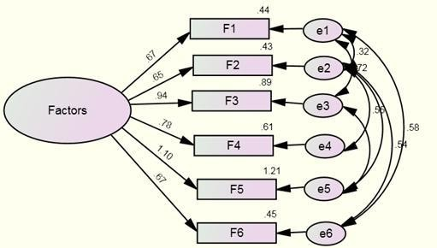 **awareness has significant influence on Reason as the standardized direct effect**

**this construct on Reason was 0.456, which is more than 0.4 (also *p* value**

**FINDINGS AND CONCLUSIONS**

**FINDINGS**

A study on investors preference towards Exchange Futures and Options covered 175 respondents (Investors) in Ernakulam District. The following are the main findings of the study;

**Findings Based On Profile Of The Respondents.**

1. It is revealed that majority of the respondents under study are male investors.

This indicate that Futures and Option trading is popular among males compared to female investors.

1. It also revealed satisfaction level among the respondents is not based on their gender.
2. The study shows that investor within the age group of 20 to 30 years are constitute major proportion of investors who trade in derivatives in Ernakulam District while investors with age above 50 years constitutes a very low proportion of investors in derivative market segment.
3. It is found out that the age of the respondents is has no significant effect on the level of satisfaction among the investors. So we can say that investor‘s satisfaction is not based on their age.
4. The study shows that investors having professional degree aredominating the Futures and Options market compared to investors with bachelor‘s degree.
5. It also found that there that level of education of the investors influence their satisfaction from derivative trading.
6. Most of the investors under the study are private sector employees constituting 60 percent of the respondents followed by professionals, Businessmen, daily wage earner and unemployed persons.
7. It can be seen from the study that occupation of the investors influences their level of satisfaction from Futures and Options trading.
8. It can be found that most of the investors under the study earn Rs. 41,000 to Rs.

50,000 per month, followed by investors more than Rs.50,000 p.m.This shows that investors with high monthly income are ready to invest in derivatives compared to low income groups. Therefore we can conclude that income of the respondents effect their level of satisfaction.

**An Insight into Derivative Trading –Findings**

1. The study shows experience of respondents in the stock market has a significant role in their derivative trading. Majority of the respondents (51.9 percent) has an experience of 0 to 5 years, followed by respondents (38.9 percent) with 6 to 10 years. Hardly 2.9 percent of respondents has an experience ranging from 15 years and above. Thus we can conclude that exposure to the stock market guides the investor who are willing to take risk to invest in futures and options.

It clearly shows that investors need to have experience to trade in the derivative market segment. Majority of the investors have an experience of 3 to 4 years. It also seen that investor with less than a year exposure to derivative market segment are trading in derivatives. Thus, we can

**BIBLIOGRAPHY**

**BOOKS AND ARTICLES**

Briys, E. (1998).Options, Futures and Exotic Derivatives: World Scientic Publishing Co.

Caution ahead of derivatives expiry subdues equity markets. (2016, March 31).

Malayala Manorama. May 12, 2016,

Commodities Agency Advised to Drop Plan to Limit Futures Contracts. (2016, February 24).

Dunbar, N. (2011). The Devil's Derivatives: The Untold Story of the Slick Traders and Hapless.

George, A J., Dr., and Anish Thomas. Financial Markets and Derivatives. First ed.

Changanacherry: Prakash Publications, 2014. Print

Gupta, S. L. (2005). Financial derivatives: theory, concepts and problems. Haug, E. G. (1998). The complete guide to option pricing formulas.

Hull, J. C. (n.d.). Options, Futures and Other Derivatives (9th Edition ed.).

Kevin, S. (2014). Commodity and Financial Derivatives (Second ed.). Delhi: Ashok K Bose PHI learning Pvt Ltd.

Kolb, R. W., & Overdahl, J. A. (2012). Financial Derivatives (3rd Edition ed.).

Nair, S. (2016, May 16). Despite key steps, commodity derivative markets face hiccu

**RESEARCH JOURNALS/WORKING PAPERS/ DISSERTATIONS**

**REFERENCES**

1. Reserve Bank of India (RBI): https://www.rbi.org.in/

2. International Monetary Fund (IMF): https://www.imf.org/

3. World Bank: https://www.worldbank.org/

4. United Nations Conference on Trade and Development (UNCTAD): https://unctad.org/

5. Ministry of Finance, Government of India: https://www.finmin.nic.in/

6. Confederation of Indian Industry (CII): https://www.cii.in/

7. The Economic Times: https://economictimes.indiatimes.com/

8. The Times of India: https://timesofindia.indiatimes.com/

9. World Economic Forum (WEF): https://www.weforum.org/

10. Organisation for Economic Co-operation and Development (OECD): https://www.oecd.or

11. Financial Times: https://www.ft.com/

12. Bloomberg: https://www.bloomberg.com/

13. World Trade Organization (WTO): https://www.wto.org/

14. CNBC: https://www.cnbc.com/

15. Pew Research Center: https://www.pewresearch.org/

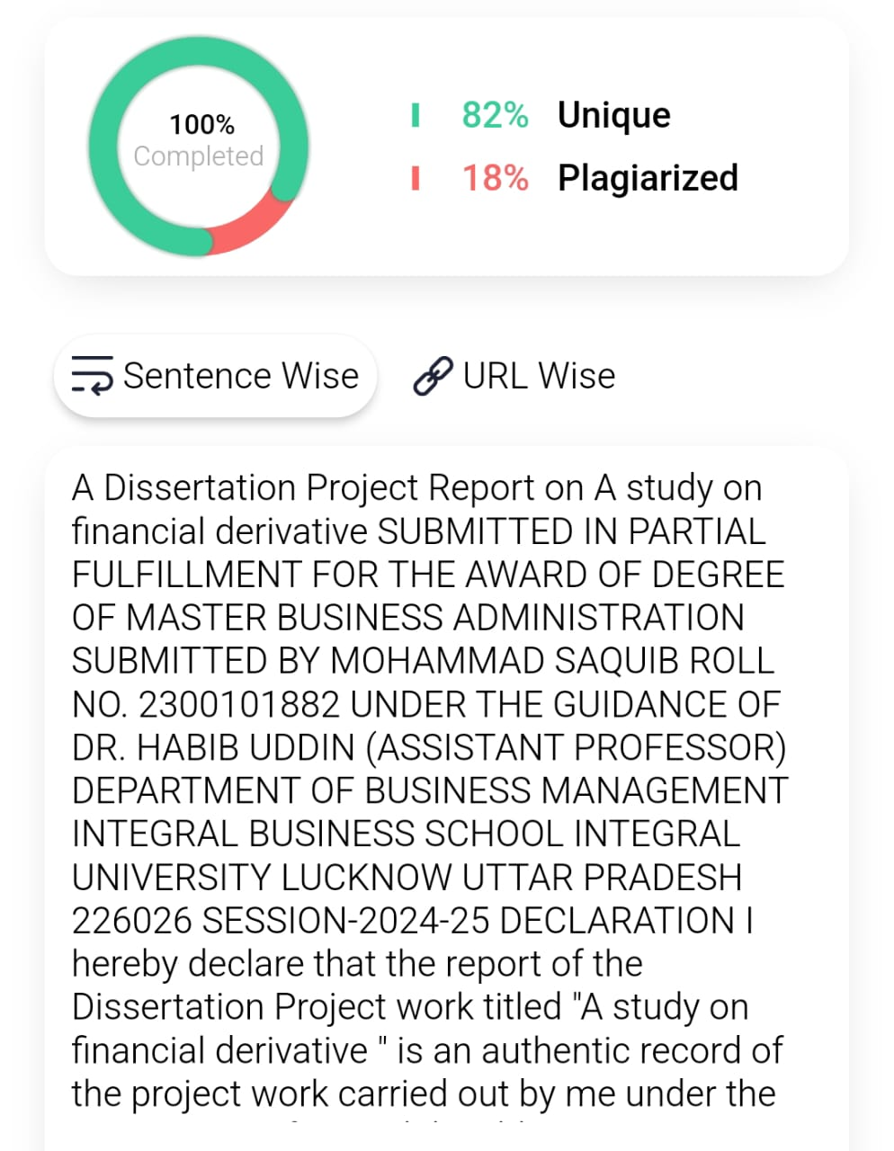**Plagiarism Report**